**Panasonic 01/17/2024**

**Project Planning**

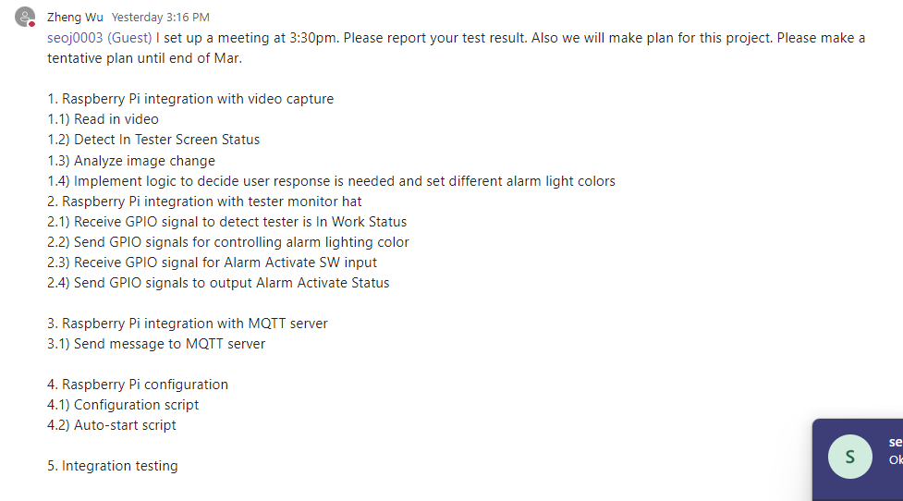

Planning Total (9 weeks – 1month & half/2months)

1. Raspberry Pi Integration with Video Capture (2-3 weeks)
   1. Video Analyzing, Detecting Tester Screen Status, Image Change Analyze (1 week)
   2. Implementing Logic for user response (1-2weeks)
2. Raspberry Pi integration with tester monitor hat (1-2 weeks)
   1. Receive and send GPIO signals
3. Raspberry Pi integration with MQTT server (1-2 weeks)
4. Raspberry Pi configuration & testing (2 weeks)

**Tester Monitor Flow Chart**

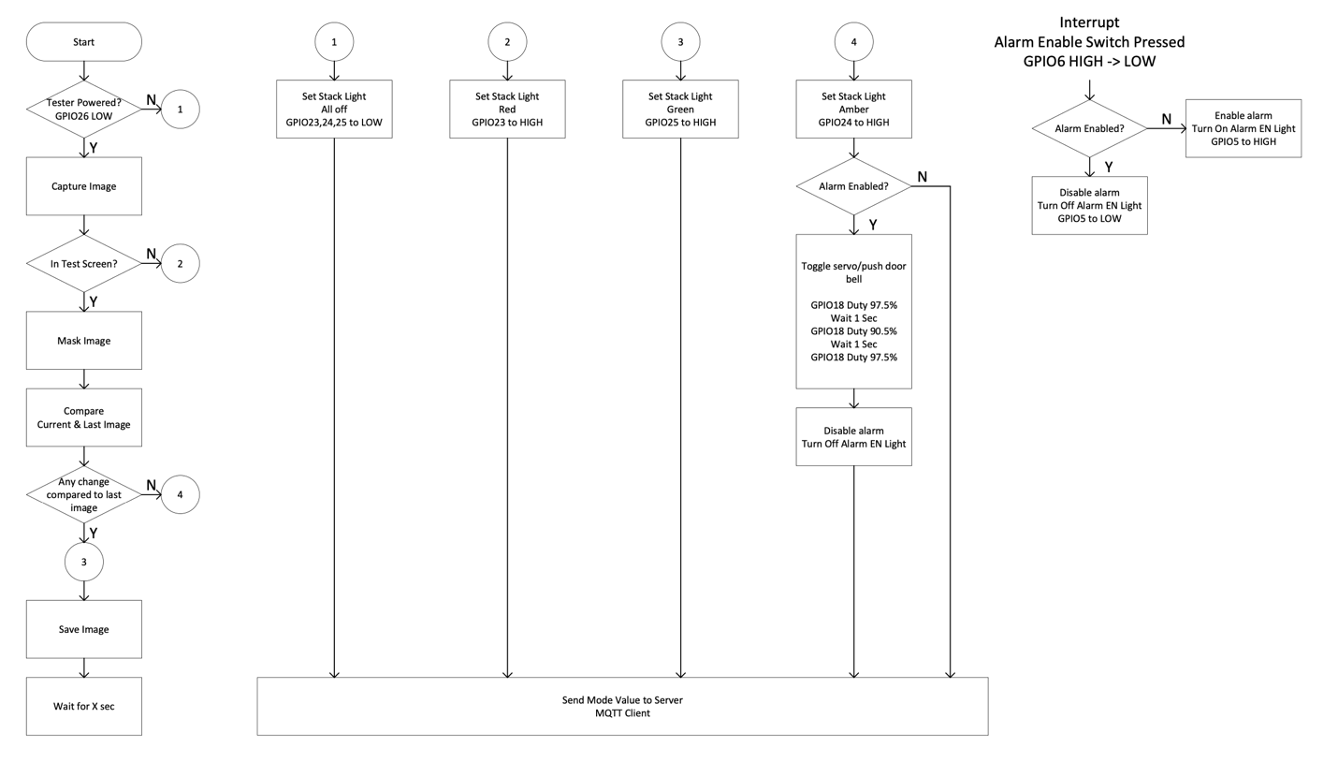

**Schematics**

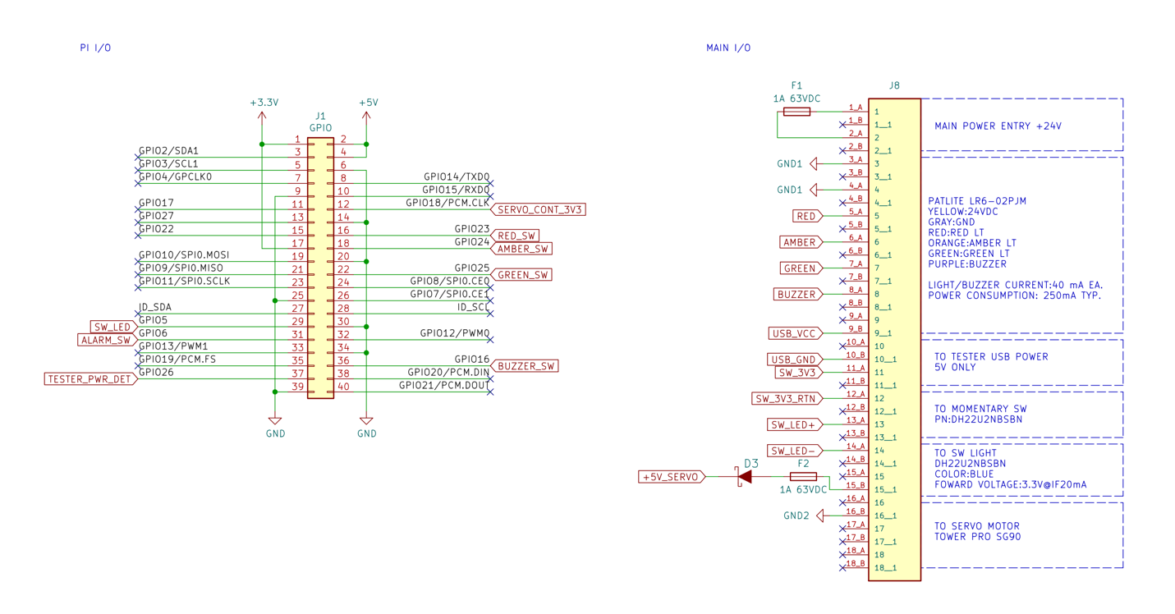

* Pin #9 & 10 is for power input for changing tester power detection status

**Code Analysis**

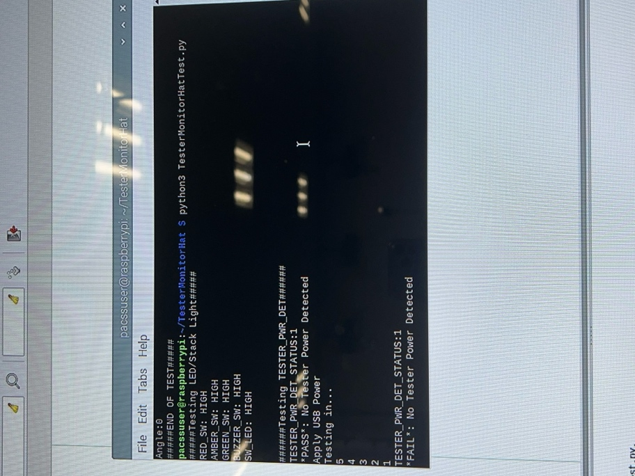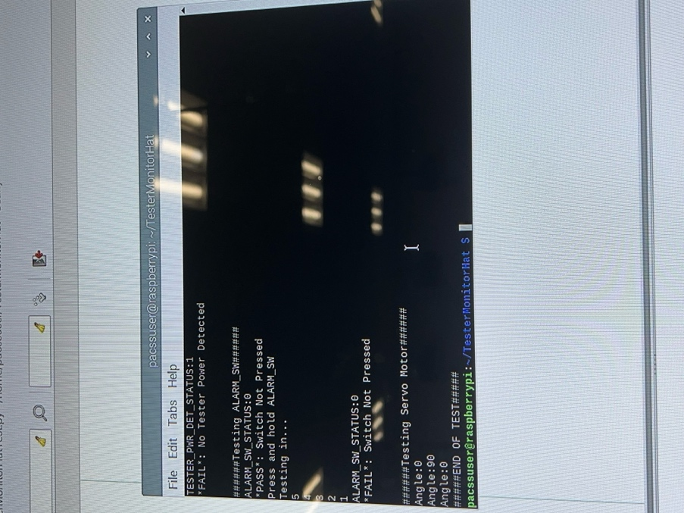

When USB is not connected to a power source:

* Testing TESTER_PWR_DET
  + TESTER_PWR_DET_STATUS: 1
  + *PASS*: No Tester Power Detected
  + (after testing) *FAIL*

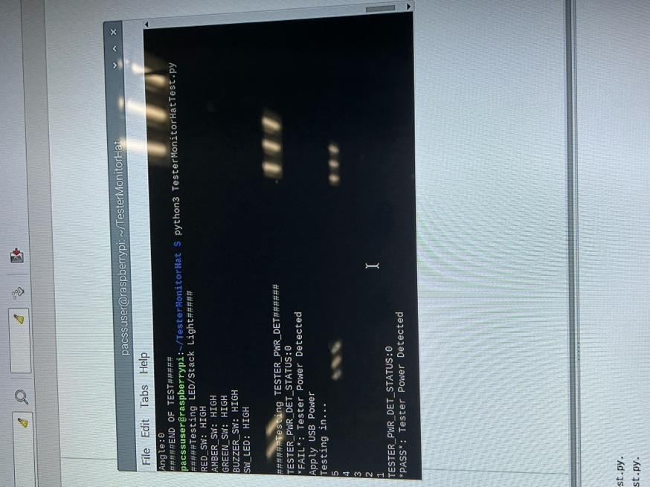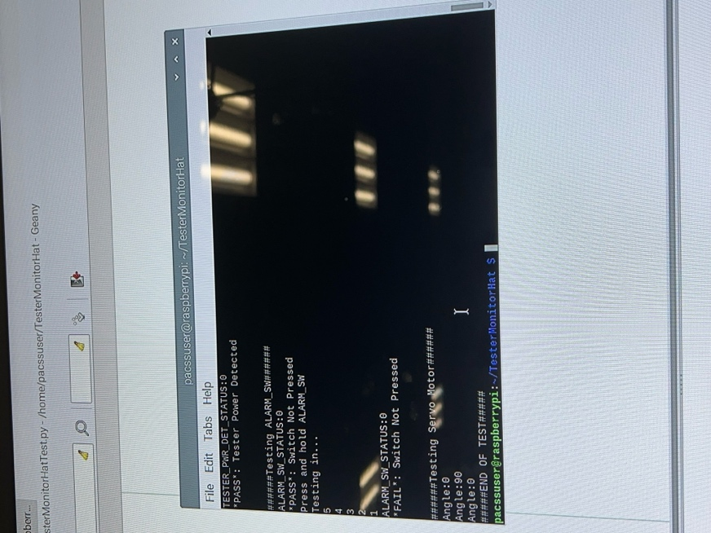

When USB is not connected to a power source:

* Testing TESTER_PWR_DET
  + TESTER_PWR_DET_STATUS: 0
  + *FAIL*: Tester Power Detected
  + (after testing) *PASS*

**PASSING RESULT**

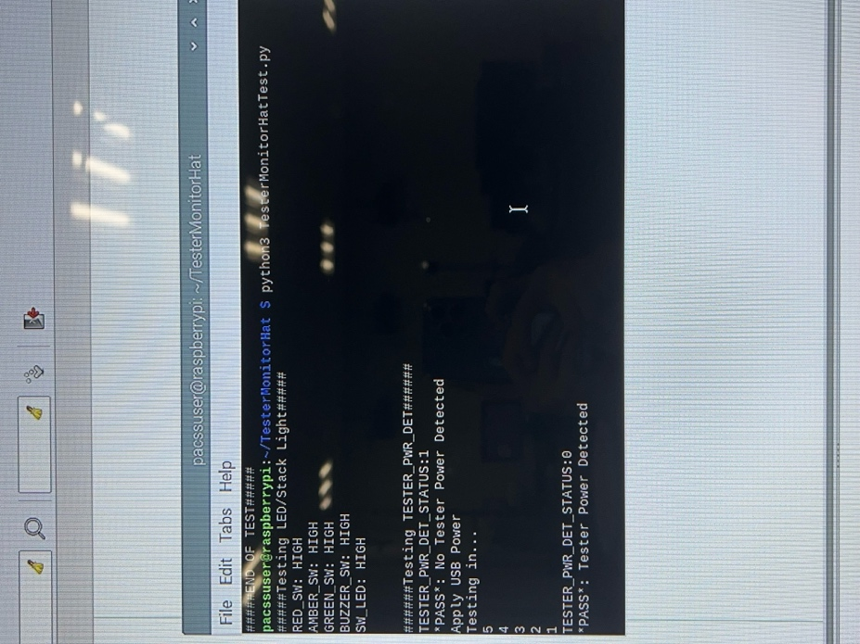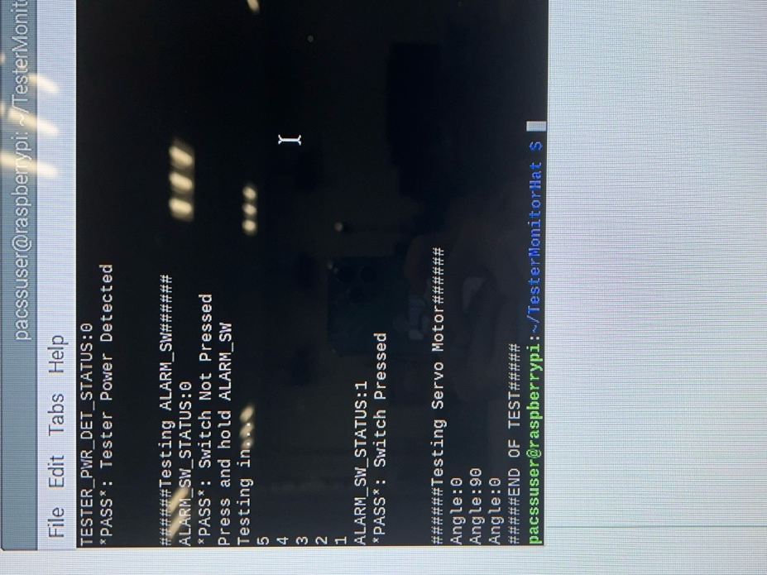

**In order to Pass the Monitor Testing**

1. Initially unplug USB 🡪 No power source
2. Initially no pressing switch

#### Testing Power Detection Status ####

* If USB is initially unplugged (no power source) 🡪 *PASS*
* During Testing timer, plug USB (yes power source) 🡪 *PASS*

#### Testing Alarm Switch ####

* If switch is initially untouched 🡪 *PASS*
* During Testing timer, press Switch 🡪 *PASS*

#### Servo Motor ####

* Rotates 90 degrees